CS 255 System Design Document

UML Diagrams

UML Use Case Diagram
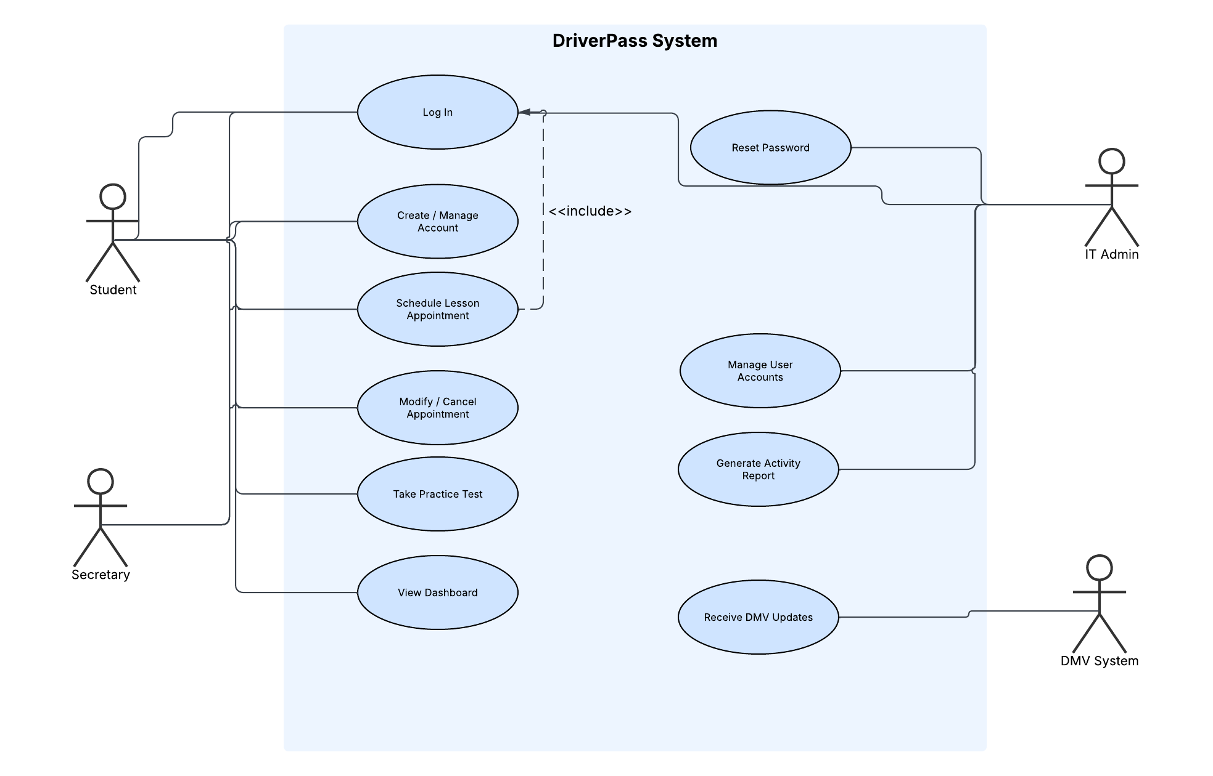

UML Activity Diagrams

Scheduling a Driving Lesson
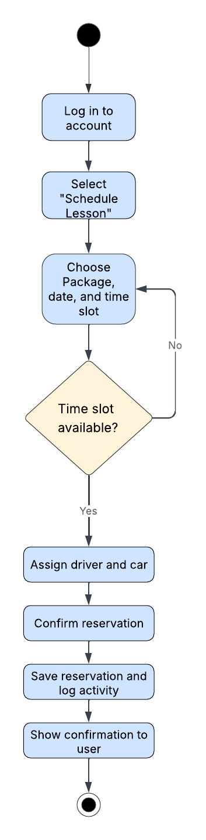

Create a Student Account
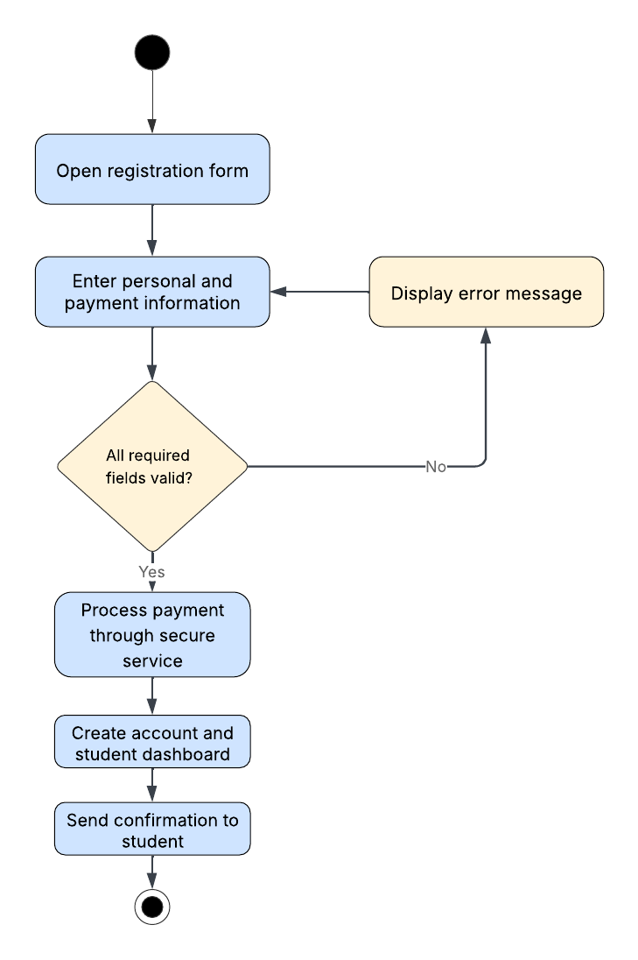

UML Sequence Diagram
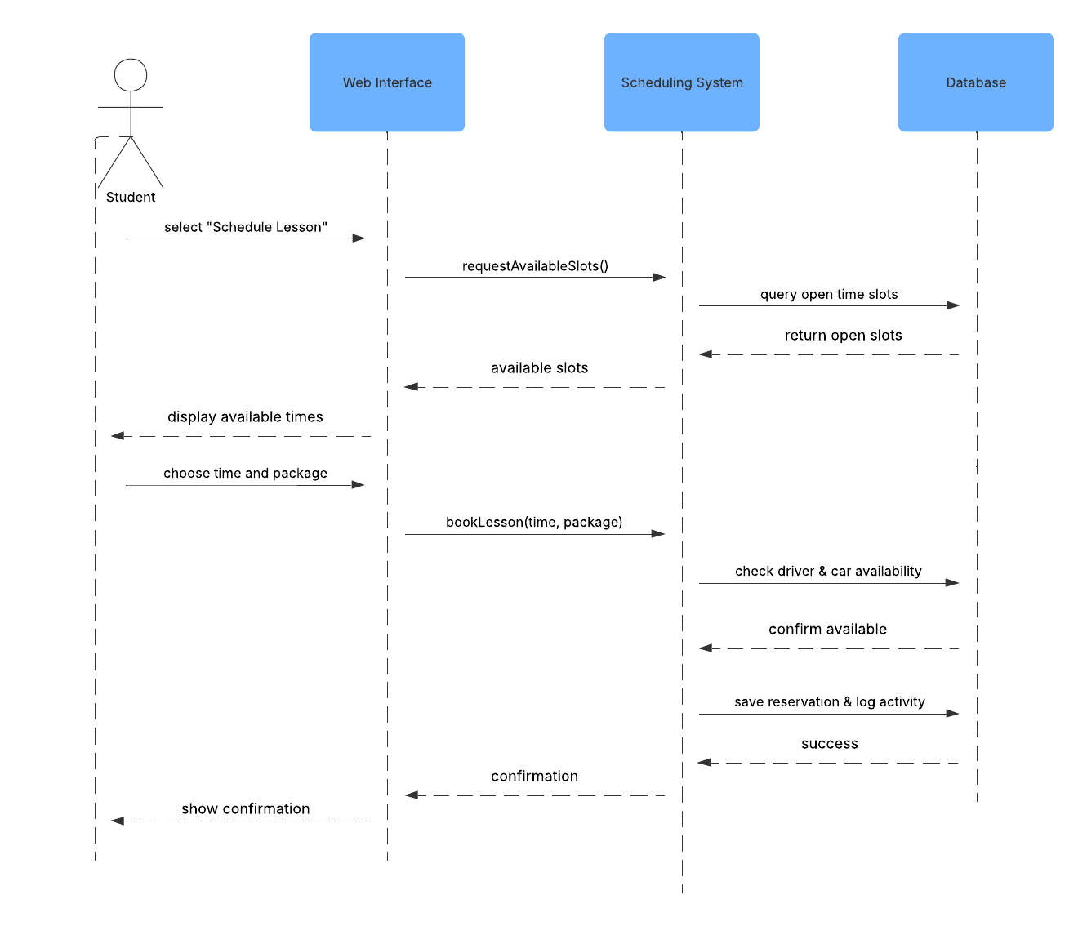

UML Class Diagram
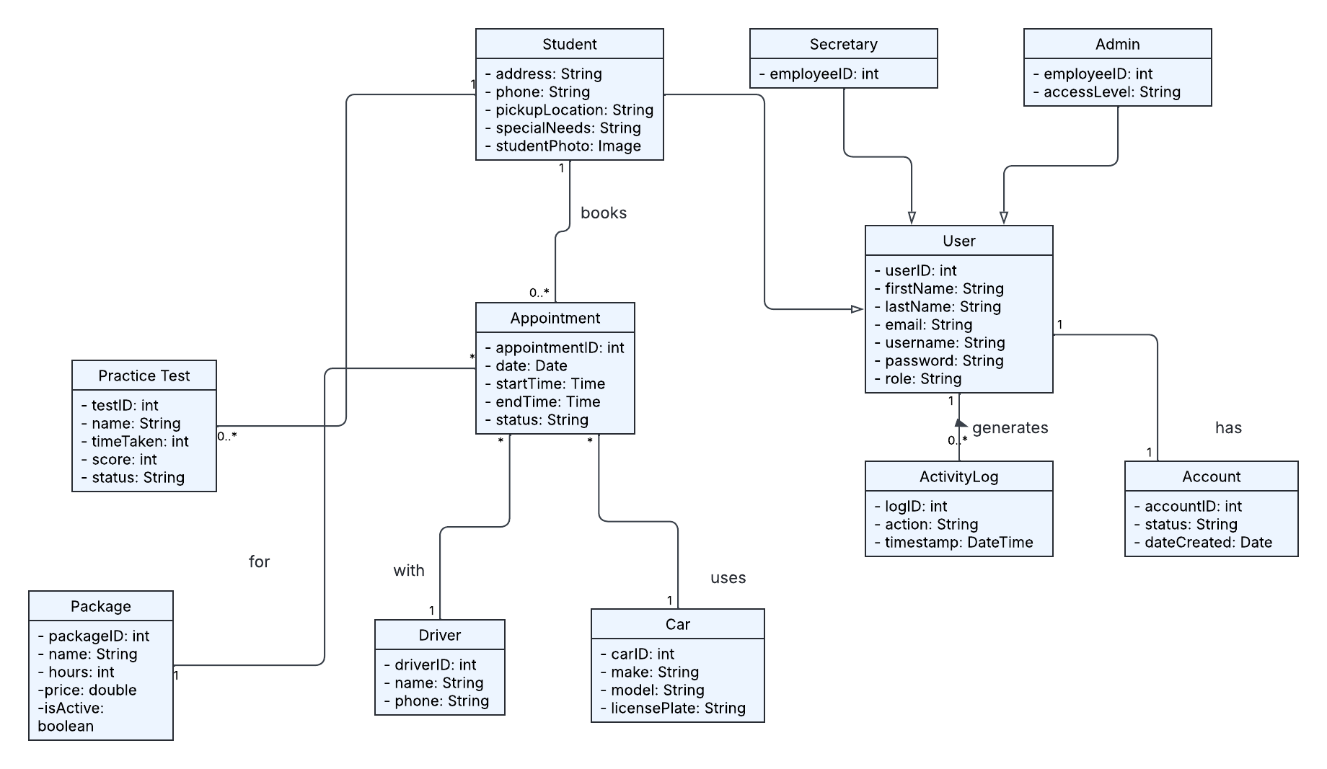

Technical Requirements

Hardware
⦁ Cloud server resources are provisioned through a cloud hosting provider.
⦁ Client devices: any standard desktop, laptop, tablet, or smartphone that the Student, Secretary, or IT Admin uses to reach the system over the internet.
⦁ Office workstations for the Secretary and IT Admin to register customers and manage accounts.

Software
⦁ A modern web browser on each client device; no software needs to be installed locally because the system is web-based.
⦁ A web application server and server-side application to run the scheduling, account, testing, and reporting logic.
⦁ A relational database management system (such as MySQL or PostgreSQL) to store accounts, appointments, drivers, cars, packages, and test results.
⦁ HTTPS/TLS encryption to secure the connection and protect personal and payment information collected during registration.
⦁ A secure third-party payment processing service to handle credit card transactions.

Tools
⦁ A version control and development environment for the development team.
⦁ Data export support so reports and records can be downloaded for use in spreadsheet software such as Excel, as the client requested.

Infrastructure
⦁ Cloud hosting that provides automatic backups, security, and infrastructure management so DriverPass staff can focus on running the business.
⦁ Role-based access control supports at least three permission levels: admin, secretary, and student.
⦁ An audit/logging service that records who created, modified, or canceled each record, supporting printable activity reports.
⦁ A secure data connection to the DMV so the system can receive updated rules, policies, and sample questions and notify admins of changes.

